WELCOME TO GOOGLE GEMINI-AI
https://deepmind.google/technologies/gemini/#introduction
https://ai.google.dev/gemini-api/docs
https://ai.google.dev/gemini-api/docs/ai-studio-quickstart
====
1-Click the given link
https://deepmind.google/technologies/gemini/#build-with-gemini
then click on ai.google.dev
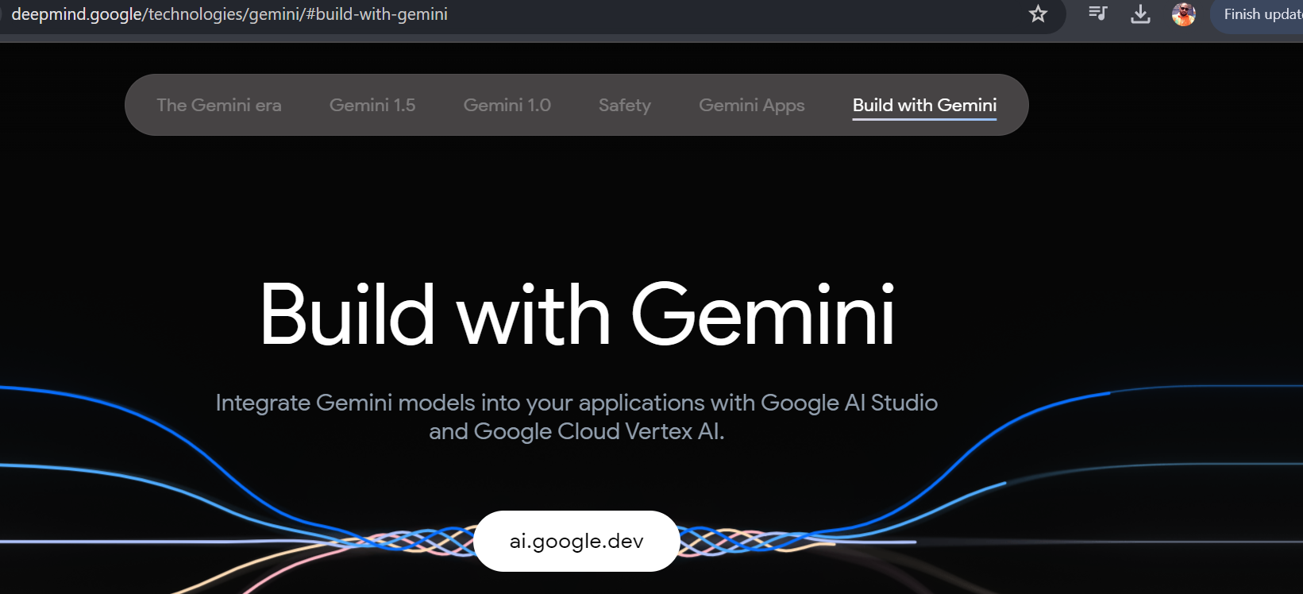
2- after click it will address to new page https://aistudio.google.com/app/prompts/new_chat for there you can create your own api key by clicking on get api key save the api key
3- create new prompt little work on basic upload image, upload audio, upload video , pdf all those things (also you can compare among gemini 1.0 & gemini 1.5 pro) click on get code
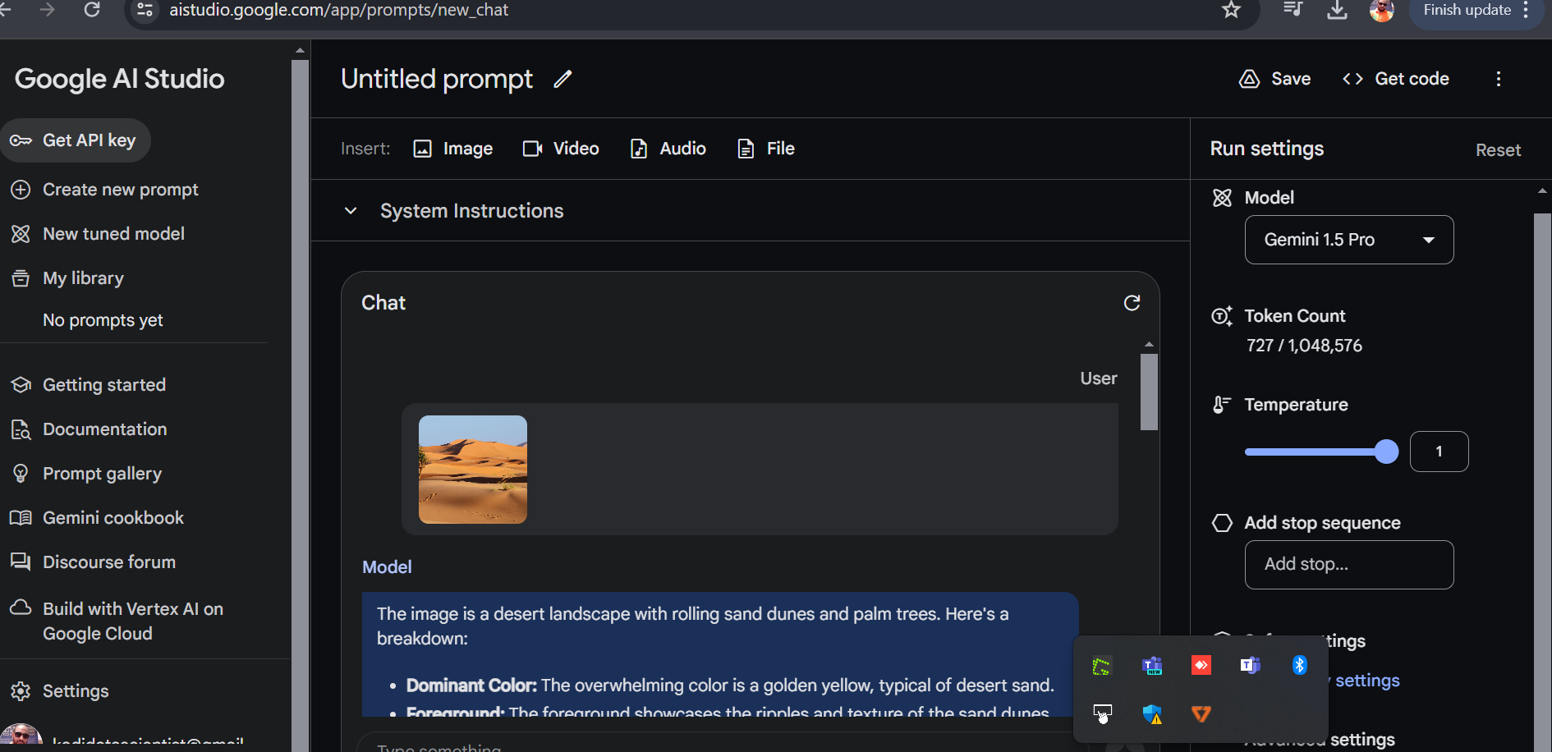
4- After creating the api key just follow the gemini given colab practicle & work on your colab application - create your own text prompt - text prompt using gemini - refer to the google colab
5- read the given document https://ai.google.dev/gemini-api/docs/get-started/python
refer to the google colab page
6- TEXT TO TEXT MODEL BUILD | IMAGE TO TEXT BASED MODEL | CONVERSATION AI CHATBOT

